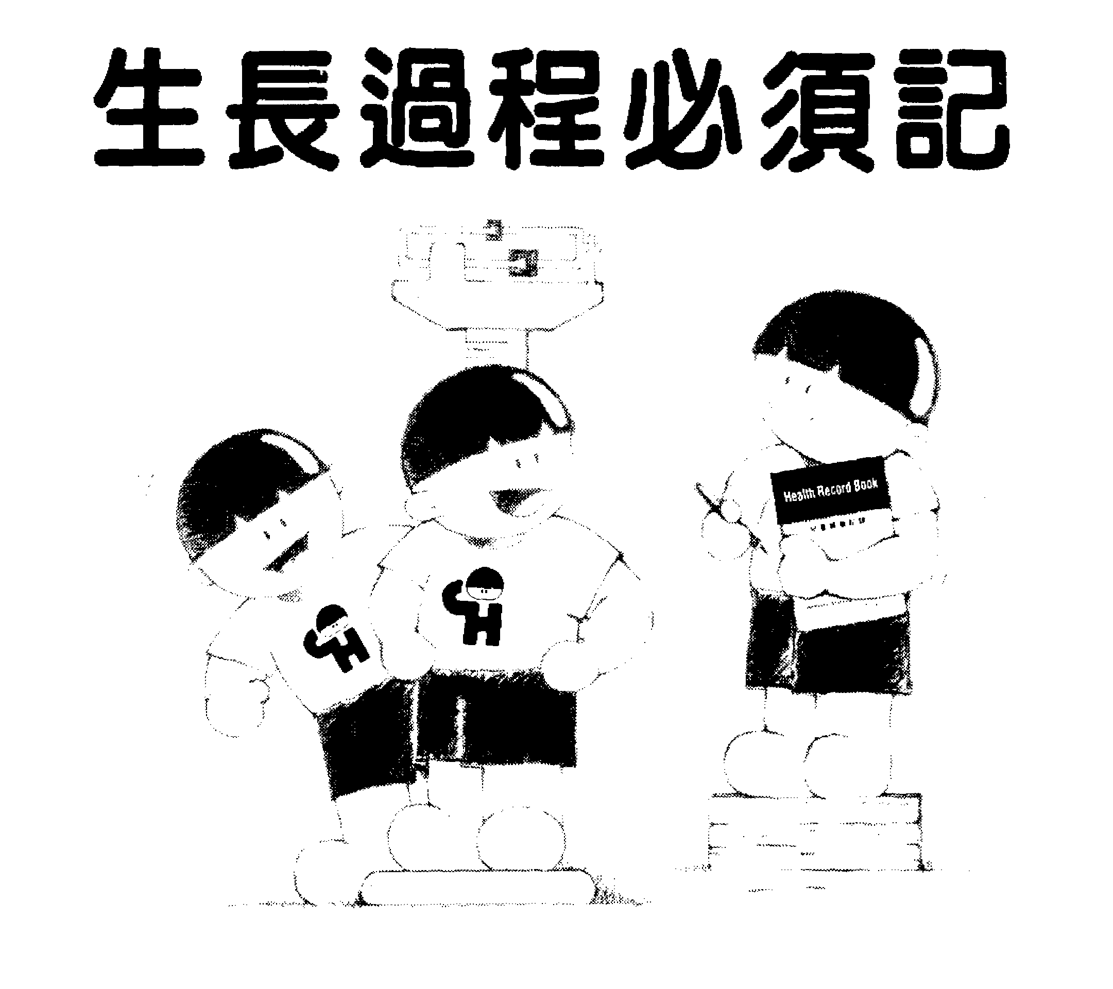

兒童健康記錄 Health Record Book
家長可以利用[兒童健康記錄] Parents will be taught how to record and 觀察和記錄孩子的成長和健康情況。 monitor the development and health of their own children using this record book.
其內容包括： Contents include the followings :
- 父母與兒童資料。 - Particulars of parents and the child
- 嬰兒圍產期與飲食記錄。 - Perinatal and feeding history
- 重要病歷與傳染病歷。 - History of significant medical and infectious disease.
- 診所和醫院醫療記錄。 - Summary of hospital / clinic visits.
- 發育及成長過程指標。 - Development milestones
- 防疫注射時間及記錄。 - Immunization programme and record
- 成長過程及牙齒長出時間表。 - Growth and dentition charts

香港兒童健康基金

HONG KONG CHILDHEALTH FOUNDATION
14/F, AIE Building, 33 Connaught Road, Central, Hong Kong Tel: 2567 2727
香港中環干諾道中三十三號亞洲大廈十四字樓 電話: 2567 2727
電郵地址：hkchf@netvigator.com 傳真號碼：2886 3166
Government Recognized Charitable Trust 政府認可慈善基金
------------------------------------------------------------------------------------------------------------
免費索取[兒童健康記錄] Free “Health Record Book”

曾經承蒙數大機構贊助現時自費，本基金於91年7月開始,免費派發數十萬本兒童健康記錄給所有雖要之小童。有意者請填妥此表格,連同6吋x8吋之回郵信封及HK$2.4郵票, 寄回 : 香港筲箕灣道172號閣樓 [香港兒童健康基金] 。
With the past sponsorship of several large organisations and now self funded, the Hong Kong Childhealth Foundation is able to distribute a few hundred thousand copies of “Health Record Book” to all children who need one as from July 1991. Those interested please return this form with a 6” x 8” self-addressed envelope + $2.40 postage to “Hong Kong Childhealth Foundation, M/F., 172 Shaukeiwan Road, Hong Kong”

本人欲索取免費之兒童健康記錄。玆附上 6吋x 8 吋之回郵信封一個及$2.40 郵費
I would like a free copy of “Health Record Book”. I enclose a self-addressed envelope measuring 6” x 8” with HK$2.40 stamps.

兒童姓名
Name of Child : _________________________ 年齡 Age : ___________________
性別 Sex : _________________________ 電話 Tel : ____________________
地 址 Address : __________________________________________________________

